Command

|  |  |  |
| --- | --- | --- |
| Action | Graphical User Interface (GUI) | Command line Interfacce |
| List the items in the current directory | Windows Explorer | ls <PATH>  -l àDetails about the items  -a àHidden items |
| Where we are now currently? |  | pwd |
| Navigate | click click | cd <PATH>  cd without parameteràgo to home dir |
| Who logged in into the system | - | who |
| What is your sign in id | Windows menu | whoami |
| Host name | - | hostname |
| Write out the parameters into the standard output | - | echo |
| Details about the loggged I n users |  | finger |
| Creating a file (if the fileis exist, update the modification date |  | Touch |
| Create a directory |  | Mkdir <PATH> |
| Write out the content of the file |  | Cat <FILE PATH> |
| Th executed commands |  | history |
| Change the permission |  | chmod <PERM DEF> <FILEPATH>  u+=-rwx  g  o  example: chmod u=rwx,g=,o+w hello.txt |
| Remove item |  | Rm |
| Link |  | Ln <SOURCE> <DEST>  -s --> Soft link |
| Running process list |  | Ps aux |
| Sleeping |  | Sleep 10 |
| Send a signal to a process |  | Kill <SIGNAL> PID |
| See environment variables |  | Env |

Standard Input/Standard Output

1. Every command/program/script have an input and an output
2. The output:
   1. It is called Standard Output (or STDOUT in short)
   2. It goes to your terminal by default, but it can be redirected!!!
   3. How to redirect into a file?
      1. COMMAND > FILEPATH à Refirect the left side’s output into the right side file: create a file, or rewrite the old one if exist
      2. COMMAND >> FILEPATH à Same, but append the content if exist
3. 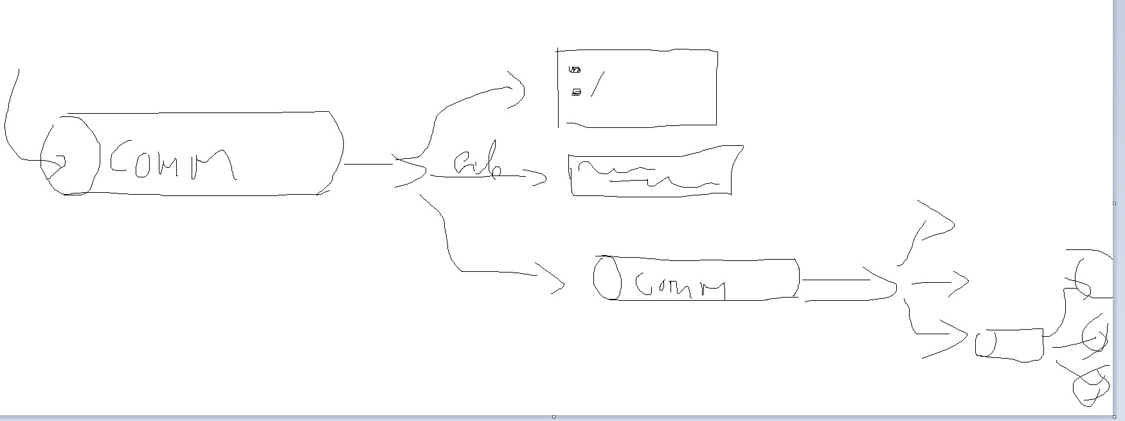

Best practice

1. Up/down arrow button
   1. You can navigate in the command history
2. Tabulator button
   1. Auto-complete
3. If you dont want to execute something: CTRL+C
4. Copy: Select the text
5. Insert: Mouse right click

Path

1. Full (absolute) path: From the root *root*
2. Relative: From the current one

General Command line things:

1. User manual page!!!!!!!!!
   1. man <COMMAND NAME>
   2. Searching in manual: type /*keyword*
      1. Next finding: n button
      2. Previous: p
   3. Quit: q
2. The parent directory: ..
3. The current directory: .

Edtiros

1. vi
   1. 2 modes: command mode, editor mode
   2. Switch to command mode: ESC button
   3. Switch to editor/insert mode: I button
   4. Some basic commands:
      1. Save --> :w
      2. Exist --> :q
      3. Save + exit --> :wq
      4. Eist without save --> :q!
2. Nano
   1. Only 1 mode. Only 15 options
      1. CTRL+char

Unix things

1. There is no such thing as a hidden fileàHidden means, the names starts with . for example .profile
2. Running proccess in a background: &
   1. E.g.: sleep 100 &
3. Link
   1. Hard links are dangerous!
      1. If a hard link remains, you did not free the spave when you remove the original file
4. Permissions
   1. The first column in the long listing format (ls -l)
   2. The first column have 10 characters
      1. The first character: the item type: -,d,l (file,directory,link)
      2. The next 9 characters are the permissions
      3. First 3 characters: u
      4. 4-6: g
      5. 7-9: o
      6. A 3 character collection means: rwx or no character in the place if no permission. Example: r-x (read and execute but no write permission)
   3. Entities
      1. User (u)
      2. Group (g)
      3. Others (o)
   4. Permission type:
      1. Read(r)
      2. Write(w)
      3. Execute(x)

|  |  |
| --- | --- |
| r | 4=2^2= 100 r-- |
| w | 2=2^1= 010 -w- |
| x | 1=2^0= 001 --x |
| rw | 4+2=6 rw- |
| rx | 4+1=5 |
| wx | 2+1=3 |
| rwx | 4+2+1=7 |
| - | 0 |

Filters

|  |  |  |
| --- | --- | --- |
| Grep | General filter. Gives back only those items, that match the pattern |  |
| head | Print the first n lines |  |
| tail | Print the last n lines |  |
| Wc | Word Count. It counts many things like character, lines, words bytes |  |
| Cut |  |  |
|  |  |  |
|  |  |  |
|  |  |  |

Exercises

1. Save the list of the elements of your home directory, into 0924/items.txt
   1. ls -al /afs/inf.elte.hu/user/s/sz/szicsa > 0924/items.txt
2. Save your history and upload it into canvas
   1. Execute the following command on the server: history > history.txt
   2. Open an FTP client (like WinScp): Find the file
   3. Download the file (drag and drop to a local directory)
   4. Find the quiz in the canvas page
   5. Upload the file
3. Our file has the following permission: user has only read, group has write and execute, others have execute. What will be the permission after I execute the following command: chmod u+rw,g-x,o=rwx myFile
   1. -rw--w-rwx
4. List only the txt files in the current directory!
   1. ls –al | grep “.txt”
5. How many items I have in the current directory
   1. ls -a | wc -w
6. How many users are logged in to the system?
   1. who | wc –l
7. How many txt files do we have in the current directory?
   1. ls -al | grep ".txt" | wc –l
8. List the first 3 lines in a file
   1. cat lines | head –3
9. List the last 2 lines in a file
   1. cat lines | tail –2
10. Give back the third line (only the third)
    1. cat lines | head -3 | tail -1